**1DOF Model:**

**fθ’**

**mg**

**L**

**l**

**T2**

**T1**

Torque equilibrium equation:

$$\ddot{θ}=\frac{\left(T2-T1\right)L+m_{p}glsinθ-\dot{θ}fl}{J}$$

$$u=T1-T1$$

Setting , when ,,.

$$\ddot{ϕ}=\frac{uL-m_{p}glϕ-\dot{ϕ}fl}{J}$$

Linear Model:

$$\left[\begin{matrix}\dot{ϕ} \\ \ddot{ϕ}\end{matrix}\right]=\left[\begin{matrix}0 & 1 \\ \frac{-m_{p}gl}{J} & -\frac{fl}{J}\end{matrix}\right]\left[\begin{matrix}ϕ \\ \dot{ϕ}\end{matrix}\right]+\left[\begin{matrix}0 \\ \frac{L}{J}\end{matrix}\right]u$$

**2DOF Model:**

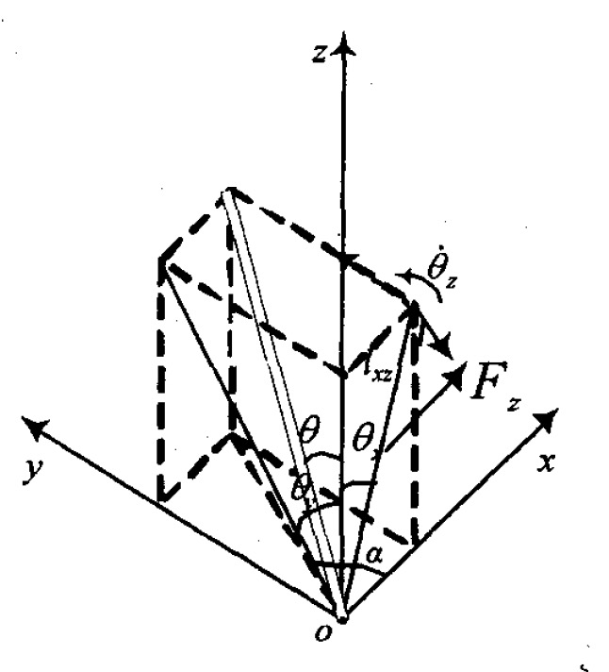

**T2**

**T1**

**T4**

**fθx’**

**fθy’**

**mg**

**T3**

By Lagrange's Equations:

$$L=T-V$$

$$\frac{d}{dt}\left(\frac{∂L}{∂\dot{θ_{x}}}\right)-\frac{∂L}{∂θ_{x}}=F$$

$$T=\frac{1}{2}m_{p}gl^{2}{\dot{θ_{x}}}^{2}$$

$$V=m_{p}glcosθ_{x}$$

$$L=T-V=\frac{1}{2}m_{p}l^{2}{\dot{θ_{x}}}^{2}-m_{p}glcosθ_{x}$$

$$\frac{d}{dt}\left(\frac{∂L}{∂\dot{θ_{x}}}\right)-\frac{∂L}{∂θ_{x}}=m_{p}l^{2}\ddot{θ_{x}}-m_{p}glsinθ_{x}$$

$$u1=T2-T1$$

$$m_{p}l^{2}\ddot{θ_{x}}-m_{p}glsinθ_{x}=u1-\dot{θ_{x}}f$$

Setting, when,,.

Setting $θ_{x}=θ+π$, when $θ≪1$, $cosθ_{x}=-1, sinθ_{x}=-θ$.

$$\ddot{θ}=\frac{-m_{p}glθ+u1-\dot{θ}f}{m_{p}l^{2}}$$

Linear Model of system 1:

$$\left[\begin{matrix}\dot{θ} \\ \ddot{θ}\end{matrix}\right]=\left[\begin{matrix}0 & 1 \\ -\frac{g}{l} & -\frac{f}{m_{p}l^{2}}\end{matrix}\right]\left[\begin{matrix}θ \\ \dot{θ}\end{matrix}\right]+\left[\begin{matrix}0 \\ \frac{1}{m_{p}l^{2}}\end{matrix}\right]u1$$

By symmetry:

Setting $θ_{y}=ϕ+π$, when $ϕ≪1$, $cosθ_{y}=-1, sinθ_{y}=-ϕ$.

$$u2=T4-T3$$

$$\ddot{ϕ}=\frac{-m_{p}glϕ+u2-\dot{ϕ}f}{m_{p}l^{2}}$$

Linear Model of system 2:

$$\left[\begin{matrix}\dot{ϕ} \\ \ddot{ϕ}\end{matrix}\right]=\left[\begin{matrix}0 & 1 \\ -\frac{g}{l} & -\frac{f}{m_{p}l^{2}}\end{matrix}\right]\left[\begin{matrix}ϕ \\ \dot{ϕ}\end{matrix}\right]+\left[\begin{matrix}0 \\ \frac{1}{m_{p}l^{2}}\end{matrix}\right]u2$$

**3DOF Model:**

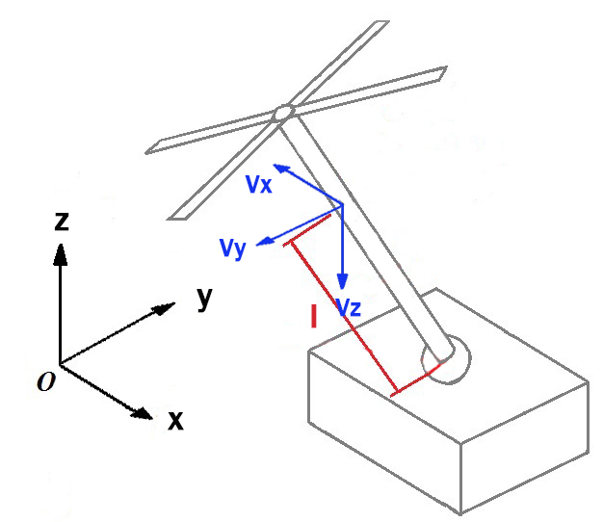

**Ft**

**O**

**mg**

**f2**

**f1**

**U2**

**U1**

$$ϕ$$

$$θ$$

$$ψ$$

$$θ$$

$$ϕ$$

$$ψ$$

Setting the coordinate system of the pendulum around the point of O, which origin is the pivot connecting the pendulum and cart, is $P=\left[\begin{matrix}x & y & z\end{matrix}\right]$.

$$z=\sqrt{l^{2}-x^{2}-y^{2}}$$

By Lagrange's Equations:

$$L=T-V$$

$$\frac{d}{dt}\left(\frac{∂L}{∂\dot{θ_{x}}}\right)-\frac{∂L}{∂θ_{x}}=F$$

$$T=Tk+Tr$$

, which Tk is the kinetic energy, and Tr is the rotational energy.

$$Tr=\frac{1}{2}J_{p}Ω^{T}Ω$$

$$Ω=\frac{P×\dot{P}}{L^{2}}=\left[\begin{matrix}y\dot{z}-z\dot{y} \\ z\dot{x}-x\dot{z} \\ x\dot{y}-y\dot{x}\end{matrix}\right]/l^{2}$$

$$Tr=\frac{1}{2}J_{p}$$

$$Tk=\frac{1}{2}m_{p}v_{p}^{2}$$

$$v_{p}=\sqrt{{v_{x}}^{2}+{v_{y}}^{2}+{v_{z}}^{2}}=\sqrt{{\dot{x}}^{2}+{\dot{y}}^{2}+{\dot{z}}^{2}}$$

$$V=m_{p}gz$$

$$L=T-V=\frac{1}{2}m_{p}\left({\dot{x}}^{2}+{\dot{y}}^{2}+{\dot{z}}^{2}\right)+\frac{1}{2}J_{p}Ω^{T}Ω-m_{p}gz$$

$$\frac{d}{dt}\left(\frac{∂L}{∂\dot{x}}\right)-\frac{∂L}{∂x}=Tx$$

$$\frac{d}{dt}\left(\frac{∂L}{∂\dot{y}}\right)-\frac{∂L}{∂y}=Ty$$

$$\frac{d}{dt}\left(\frac{∂L}{∂ψ}\right)-\frac{∂L}{∂ψ}=ft$$

$$u1=T2-T1-\dot{x}f$$

$$u2=T4-T3-\dot{y}f$$

**Position Model:**

$$R_{x}\left(ϕ\right)=\left[\begin{matrix}1 & 0 & 0 \\ 0 & cos⁡(ϕ) & sin⁡(ϕ) \\ 0 & -sin⁡(ϕ) & cos⁡(ϕ)\end{matrix}\right]$$

$$R_{y}\left(θ\right)=\left[\begin{matrix}cos⁡(θ) & 0 & -sin⁡(θ) \\ 0 & 1 & 0 \\ sin⁡(θ) & 0 & cos⁡(θ)\end{matrix}\right]$$

$$R_{z}\left(ψ\right)=\left[\begin{matrix}cos⁡(ψ) & sin⁡(ψ) & 0 \\ -sin⁡(ψ) & cos⁡(ψ) & 0 \\ 0 & 0 & 1\end{matrix}\right]$$

The composite rotation matrix R depends on the order in which the roll, pitch and yaw rotations are applied as follows:

$$R_{zyx}={\left(R_{x}\left(ϕ\right)R_{y}\left(θ\right)R_{z}\left(ψ\right)\right)}^{T}$$

$$=\left[\begin{matrix}\cos\left(ψ\right)\cos\left(θ\right) & -\sin\left(ψ\right)\cos\left(ϕ\right)+\cos\left(ψ\right)\sin\left(θ\right)\sin\left(ϕ\right) & \sin\left(ψ\right)\sin\left(ϕ\right)+\cos\left(ψ\right)\sin\left(θ\right)\cos\left(ϕ\right) \\ \sin\left(ψ\right)\cos\left(θ\right) & \cos\left(ψ\right)\cos\left(ϕ\right)+\sin\left(ψ\right)\sin\left(θ\right)\sin\left(ϕ\right) & -\cos\left(ψ\right)\sin\left(ϕ\right)+\sin\left(ψ\right)\sin\left(θ\right)\cos\left(ϕ\right) \\ -\sin\left(θ\right) & \cos\left(θ\right)\sin\left(ϕ\right) & \cos\left(θ\right)\cos\left(ϕ\right)\end{matrix}\right]$$

$$\left[\begin{matrix}Tx \\ Ty \\ Tz\end{matrix}\right]=R_{zyx}\left[\begin{matrix}u1 \\ u2 \\ 0\end{matrix}\right]=\left[\begin{matrix}u1\cos\left(ψ\right)\cos\left(θ\right)-u2\sin\left(ψ\right)\cos\left(ϕ\right)-\sin\left(ϕ\right)\sin\left(θ\right)\cos\left(ψ\right) \\ u2\cos\left(ϕ\right)\cos\left(ψ\right)+\sin\left(ϕ\right)\sin\left(ψ\right)\sin\left(θ\right)+u1\sin\left(ψ\right)\cos\left(θ\right) \\ u2\sin\left(ϕ\right)\cos\left(θ\right)-u1\sin\left(θ\right)\end{matrix}\right]$$

External moment vectors on each axis of the coordinate system:

$$\sum{M}=I\dot{ω}+ω(Iω)$$

Angular velocity around each axis:

$$ω=\left[\begin{matrix}p & q & r\end{matrix}\right]$$

Rotating inertia of three axis of this system:

$$I=diag\left[\begin{matrix}I_{x} & I_{y} & I_{z}\end{matrix}\right]$$

Setting as the

$$\sum{M}=\left[\begin{matrix}τ_{p} \\ τ_{q} \\ τ_{r}\end{matrix}\right]=\left[\begin{matrix}Lu1 \\ Lu2 \\ dFt\end{matrix}\right]=\left[\begin{matrix}Lk_{p}\left(ω_{2}^{2}-ω_{1}^{2}\right)-\dot{x}f \\ Lk_{p}\left(ω_{4}^{2}-ω_{3}^{2}\right)-\dot{y}f \\ dFt\end{matrix}\right]$$

$$\left[\begin{matrix}\dot{p} \\ \dot{q} \\ \dot{r}\end{matrix}\right]=\left[\begin{matrix}\frac{I_{y}-I_{z}}{I_{x}}qr-Lk_{p}\left(ω_{2}^{2}-ω_{1}^{2}\right)-\dot{x}f \\ \frac{I_{y}-I_{x}}{I_{y}}pr-Lk_{p}\left(ω_{4}^{2}-ω_{3}^{2}\right)-\dot{y}f \\ \frac{I_{x}-I_{y}}{I_{z}}pq+dFt\end{matrix}\right]$$

The relationship between Euler angular velocity and $ω$ be expressed as:

$$\left[\begin{matrix}\dot{p} \\ \dot{q} \\ \dot{r}\end{matrix}\right]=\left[\begin{matrix}1 & t & 0 \\ 0 & cos⁡(ϕ) & sin⁡(ϕ) \\ 0 & -sin⁡(ϕ) & cos⁡(ϕ)\end{matrix}\right]\left[\begin{matrix}\dot{p} \\ \dot{q} \\ \dot{r}\end{matrix}\right]$$

**Table of Parameters:**

|  |  |  |  |
| --- | --- | --- | --- |
| Symbol | Definition | Symbol | Definition |
| $$ϕ$$ | angle (rad) between pendulum and y axis upward | $$θ$$ | angle (rad) between pendulum and y axis downward |
| $$D$$ | Disturbance from the cart | $$m_{p}$$ | Mass of pendulum |
| $$T_{1}$$ | Trust force from the right propeller | $$T_{2}$$ | Trust force from the left propeller |
| $$s$$ | direction of the rotation | $$l$$ | Distance from the origin to the mass center of the pendulum |
| $$g$$ | Gravity | $$f$$ | Friction disturbance (such as air) |
| $$J$$ | Moment of inertial of the pendulum | $$L$$ | length of the pendulum |
| $$l_{i}$$ | Radius of propeller | $$C_{D}$$ | Drag coefficient of propeller |
| $$C_{DF}$$ | Zero lift drag | $$C_{L}$$ | Lift coefficient of propeller |
| $$AR$$ | Aspect Ratio | $$SE$$ | Span efficiency factor |
| $$ω_{i}$$ | Velocity of one propeller | $$F_{D}$$ | Drag force of propeller |
| $$f_{m}$$ | Resistance of propeller motor | $$K_{V}$$ | Propeller motor back emf constant |
| $$K_{Q}$$ | Propeller motor torque constant |  |  |
| $$V_{quad}$$ | Voltage of propeller velocity | $$u_{i}$$ | Command of Propeller |
| $$u_{max}$$ | Max propeller command | $$d$$ | Distance from the top center to the propeller center |
| $$ω$$ | Angular velocity of pendulum about each axis | $$I$$ | Rotating inertia of three axis of the system |
|  |  |  |  |